|  |  |
| --- | --- |
|  | **PIHAK BERKUASA PENERBANGAN AWAM MALAYSIA**  **(CIVIL AVIATION AUTHORITY OF MALAYSIA)**  **APPLICATION FOR UNMANNED AIRCRAFT SYSTEM (UAS) / DRONE**  (Regulation 140-144 to be read along with regulation189 – CAR 2016) |

This form is to be filled up **by the person having management of the UA**, and not another person who may, for example, have contracted with the operator to have work done. Application form and supporting documents needs to be submitted at least 14 days before the proposed activity date to [drone.atf@caam.gov.my](mailto:drone.atf@caam.gov.my) to avoid any delay. However, please take note that certain approval may take a longer period due to its complexity (e.g., operations within the airport).

**SECTION I : PERSONAL PARTICULARS OF THE ACCOUNTABLE MANAGER**

|  |  |
| --- | --- |
| Full Name |  |
| Passport/NRIC |  |
| Name of Company |  |
| Company Registration Number |  |
| Postal Address |  |
| Telephone / Mobile No |  |
| Fax Number |  |
| Email |  |

The Accountable Manager (AM) usually termed as CEO or Director is the personnel who is accountable for safety and corporate compliance. This person shall provide the necessary resources to ensure all operations and maintenance can be safely conducted to meet the obligations, goals and objectives including finance and human resources. The AM is accountable to ensure that any operation conducted is within the compliance of the legislation - Civil Aviation Regulation 2016 and any other State or Local Law pertaining UAS activity. For individual applicants, the applicant shall be the Accountable Manager.

**SECTION II : REMOTE PILOT DETAILS**

*Please add on to the list if there are any additional pilots*

|  |  |  |  |  |  |  |  |
| --- | --- | --- | --- | --- | --- | --- | --- |
| **No.** | **Name** | **Passport/NRIC** | **Nationality** | **Brand/Model of UAS** | **Details of training/course(s) attended** | **Details** | |
|  |  |  |  |  |  | Total Hours |  |
| Last Date Flown |  |
|  |  |  |  |  |  | Total Hours |  |
| Last Date Flown |  |
|  |  |  |  |  |  | Total Hours |  |
| Last Date Flown |  |
|  |  |  |  |  |  | Total Hours |  |
| Last Date Flown |  |
|  |  |  |  |  |  | Total Hours |  |
| Last Date Flown |  |
|  |  |  |  |  |  | Total Hours |  |
| Last Date Flown |  |

**SECTION III : UNMANNED AIRCRAFT SYSTEM SPECIFICATIONS**

*Please add on to the list for each model if more than one model of UAS being used.*

|  |  |  |
| --- | --- | --- |
| Brand/model of Unmanned Aircraft (UA) | : |  |
| Type of UAS (Quadcopter, Hexacopter, VTOL, Fixed wing, etc.) | : |  |
| UA Product Serial Number | : |  |
| SIRIM UAS Certification. 1. Company:  a. MCMC Label Serial Number; b. Type Approval / Certificate of Conformity (Serial Number); or c. Special Approval Certificate (Serial Number).  2. Individual:  a. MCMC Label Serial Number; or  b. Special Approval Clearance Letter (CL Number). | : |  |
| Weight (kg) | : |  |
| Length (m) | : |  |
| Wingspan (m) | : |  |
| Power source | : |  |
| Maximum flight duration (minutes) | : |  |
| Maximum speed (m/s) | : |  |
| Maximum height capable (m) | : |  |
| Maximum distance capable (m) | : |  |
| List the brands and models of all wireless transmitting devices used, including radio controller, video, etc | : |  |
| List the frequencies used by each model | : |  |
| List the output power of each model | : |  |
| **TOTAL NUMBERS OF UNMANNED AIRCRAFT USED:** | : |  |

**SECTION IV : RISK ASSESSMENT**

The purpose of the Risk Assessment Section is for the operator to consider all hazards which are possible during the intended UAS operation. There are 2 sections in the Risk Assessment Form to be completed.

*Please add on to the list for each operation if more than one operation is intended.*

|  |  |  |
| --- | --- | --- |
| **Location:** | **Blocked Flight Date / Time:**  (For NOTAM Purposes)  Example:  From 01/01/2020 (0900 hours) to  14/01/2020 (1700 hours)  **Specific Flight Activity Date / Time:**  Example:  Day 1 (Date / Time):  01/01/2020 (0900 – 1700 hours)  Day 2 (Date / Time):  02/01/2020 (0900 – 1200 hours)  **Flight Duration per activity (minutes):** | **Job / Task Name (Descriptions):** |
| **Job / Task Category:**  Example:  (Aerial Surveillance / Mapping / Inspection / Videography / Photography / Spraying / Demonstration / Recreational etc.) | **Operation Type:** (e.g. VLOS, EVLOS) | **Maximum Height of operations (meters):** |

| **S/N** | **Hazard** | **Phase(s) of Flight** | **Consequence(s)** | **Causal Factor(s)** | **Control / Recovery Measures** | **Risk Level after Measures** | **Personnel-in-charge** |
| --- | --- | --- | --- | --- | --- | --- | --- |
| **Section A: Risk Assessment for Required Type of Operations** | | | | | | | |
| ***E.g.*** | ***Accidental flying into restricted airspace*** | ***Take-off, Mid-flight, Approach, Landing*** | ***Collision with manned aircraft*** | ***Lapse in active monitoring of UAS’s position/altitude/heading*** | ***Consider people, machine & environment***  ***Pilot must actively monitor UAS flight parameters and maintain UAS within stipulated area of operations.***  ***Ensure continuous radio link between UAS operator and Unmanned aircraft throughout flying phase.***  ***Monitor wind speed in area of operation. Terminate UAS flying when wind speed excess stipulated limits.*** | ***High*** | ***Pilot Tan Lee***  ***&***  ***Safety officer Lim Bee Seng*** |
| 1. |  |  |  |  |  |  |  |
| 2. |  |  |  |  |  |  |  |

| **S/N** | **Hazard** | **Phase(s) of Flight** | **Consequence(s)** | **Causal Factor(s)** | **Control / Recovery Measures** | **Risk Level after Measures** | **Personnel-in-charge** |
| --- | --- | --- | --- | --- | --- | --- | --- |
| **Section B: Risk Assessment for Area of Operations** | | | | | | | |
| ***E.g.*** | ***Built-up areas in the vicinity of the area of operations*** | ***Mid-flight*** | ***Drone collides with building and crash lands on nearby people and/or neighbouring building(s).*** | ***Loss of visual line of sight between UAS and operator*** | ***Consider people, machine & environment***  ***Pilot must maintain visual contact with UAS at all times.***  ***Operate UAS within published radio range.***  ***Maintain safe distance from public roads, buildings and personnel.*** | ***Medium*** | ***Pilot Tan Lee***  ***&***  ***Safety officer Lim Bee Seng*** |
| 1. |  |  |  |  |  |  |  |
| 2. |  |  |  |  |  |  |  |
| 3. |  |  |  |  |  |  |  |

**Risk Severity Category**

|  |  |  |  |  |  |
| --- | --- | --- | --- | --- | --- |
| **Risk Probability**  Either qualitative or quantitative assessment | **Risk Severity** | | | | |
| **Catastrophic** | **Hazardous** | **Major** | **Minor** | **No effect** |
| **Probable**  *Anticipate to occur >=1x during the entire system/operational life of an item; or*  *Once in 1000 to 10,000 (hrs)* | **High** | **High** | **Medium** | **Low** | **Low** |
| **Remote**  *Unlikely to occur to each item during its total life. May occur several times in the life of an entire system or fleet; or*  *Once in 10,000 to 100,000 (hrs)* | **High** | **High** | **Medium** | **Low** | **Low** |
| **Extremely Remote**  *Not anticipated to occur to each item during its total life. May occur a few times in the lift of an entire system or fleet; or*  *Once in 100,000 to 1,000,000 (hrs)* | **Medium** | **Medium** | **Medium** | **Low** | **Low** |
| **Extremely Improbable**  *It is not anticipated to occur during the entire operational life of an entire system or fleet; or*  Below once in 1,000,000 (hrs) | **Low** | **Low** | **Low** | **Low** | **Low** |
| **Failure Condition in a UAS:**  A condition having an effect on the UAS, either direct of consequential, which is caused or contributed to by one or more failures or errors considering flight phase and relevant adverse operational or environmental conditions or external events  **Catastrophic**: Failure would prevent continued safe flight and landing resulting in (a) one or more fatalities or serious injury to persons or major property damage external to the UAS, (b) uncontrolled loss of aircraft  **Hazardous:** Failure would reduce the capability of the aircraft or the ability of the crew to cope with adverse operating conditions to the extent that there would be the following:   1. Physical distress to persons or property damage external to the UAS possibly including injuries 2. A large reduction in safety margins or functional capabilities 3. Higher workload such that the flight crew cannot be relied upon to perform their tasks accurately or completely.   **Major:** Failure would reduce the capability of the aircraft or the ability of the crew to cope with adverse operating conditions to the extent that there would be   1. Potential for physical discomfort to persons or minor property damage external to UAS 2. A significant reduction in safety margin or functional capabilities 3. A significant increase in crew workload or in conditions impairing crew efficiency   **Minor:** Failure would not significantly reduce the aircraft safety and involve crew actions that are well within their capabilities. It may include slight reduction in safety margins or functional capabilities, slight increase in crew workload (e.g. routine flight plan change)  **No effect:** Failure would have no effect on safety, i.e., operational capability of the aircraft or increase workload of the crew  **Risk Level (after minimising procedures taken into account)**  **H** – High  **M** – Medium  **L** –Low | | | | | |

**SECTION V : FLIGHT PLANNING OF OPERATION AREA**

*Please add on to the list for each area of operation if more than one area of operation is intended.*

**Flight Planning for UAS Operation**

Overview

There is a **total of 3 parts** in preparing the flight planning for UAS operation. Please complete all relevant sections.

**PART A - Illustration of the entire activity area.**

The applicant shall submit the entire activity area using a map application (e.g., Google Map etc.) with annotation **of take-off / landing site.**

The entire operating zone should be marked and its GPS co-ordinates, as suggested in the list below:

Green Area (Activity Area): Activity area for all intended RPA flight phases (Take-off, Mid-flight, Approach and landing)  
  
Yellow Line (Caution Area): Yellow line is operator's declared boundary to make sure that the RP is in a standby condition/mode in case where the RPA accidentally encroached the yellow line. The RP is expected to fly manually, or the flight control system is programmed to return back to green area safely.

Red Line (Emergency Zone): Red line starts as the operator's declared boundary dedicated for any emergency sequence that may arise during the conduct of UA operations. Emergency sequence may vary from manufacturer to manufacturer. The main purpose of this sequence is to ensure that the RPA lands safely or, to ensure that the ground risk towards people/vehicles/buildings is reduced.

Blue Line (Boundary Line) may act as the worst-case fall zone in case of emergency procedures carried out on passing the red zone. At no time the UA can be operated out of the blue boundary line.

The distance of the Green Area to the Blue Boundary shall be the same distance of the height. Example:

|  |  |  |  |  |  |
| --- | --- | --- | --- | --- | --- |
| **Example: Flight Operations Airspace Overview for LICC carpark Airfield and LICC observation deck area** | | | | |  |
|  | | | | |
| **Zone** | 1 | 2 | 3 | 4 |
| **Activity**  **(Green Zone)** | 6°18'06.2"N 99°51'21.6"E | 6°18'06.6"N 99°51'23.7"E | 6°18'08.4"N 99°51'23.3"E | 6°18'08.2"N 99°51'21.2"E |
| **Geo-fencing (Yellow Zone)** | 6°18'06.5"N 99°51'20.9"E | 6°18'06.1"N 99°51'21.0"E | 6°18'06.5"N 99°51'22.5"E | 6°18'06.8"N 99°51'22.5"E |
| **Risk**  **(Red Zone)** | 6°18'05.1"N 99°51'20.1"E | 6°18'05.9"N 99°51'25.6"E | 6°18'09.7"N 99°51'24.7"E | 6°18'09.3"N 99°51'20.8"E |
| **Boundary**  **(Blue Zone)** | 6°18'06.3"N 99°51'18.4"E | 6°18'04.9"N 99°51'18.8"E | 6°18'05.3"N 99°51'20.0"E | 6°18'06.7"N 99°51'19.7"E |

KMZ File Structure

The activity area map drawn on map application (e.g.: Google Earth) shall be saved in KMZ format using folder structure as shown in the picture below: -

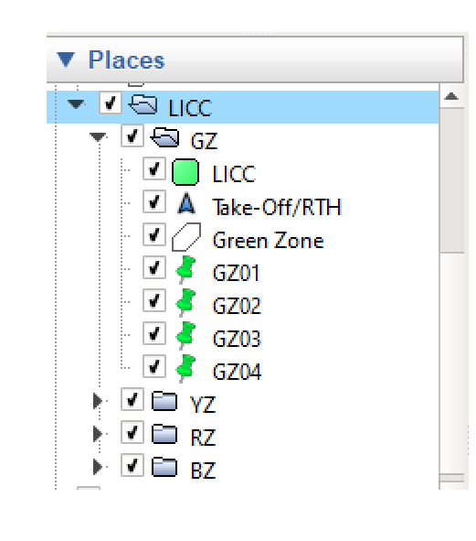

GZ – Green Zone

YZ – Yellow Zone

RZ – Red Zone

BZ – Blue Zone

**PART B – Flight Mission (If Applicable)**

The Accountable Manager shall submit the flight mission (screenshot) if UAS activity utilizing automated flight assistance for its navigation and operation.

The flight mission details shall include: -

|  |  |  |
| --- | --- | --- |
| **No** | **Flight Mission** | **Description** |
| 1 | Flight Mission Planner Application Name |  |
| 2 | Flight Mission Planner Platform (Android/iOS/Windows/Others) |  |
| 3 | Mission Type (Survey, Inspection, etc) |  |
| 4 | Total Distance Travel (km) |  |
| 5 | Mission Speed (m/s) |  |
| 6 | Total Mission Time Estimation (min) |  |
| 7 | Mission Altitude (m) |  |
| 8 | No. of Battery Use |  |

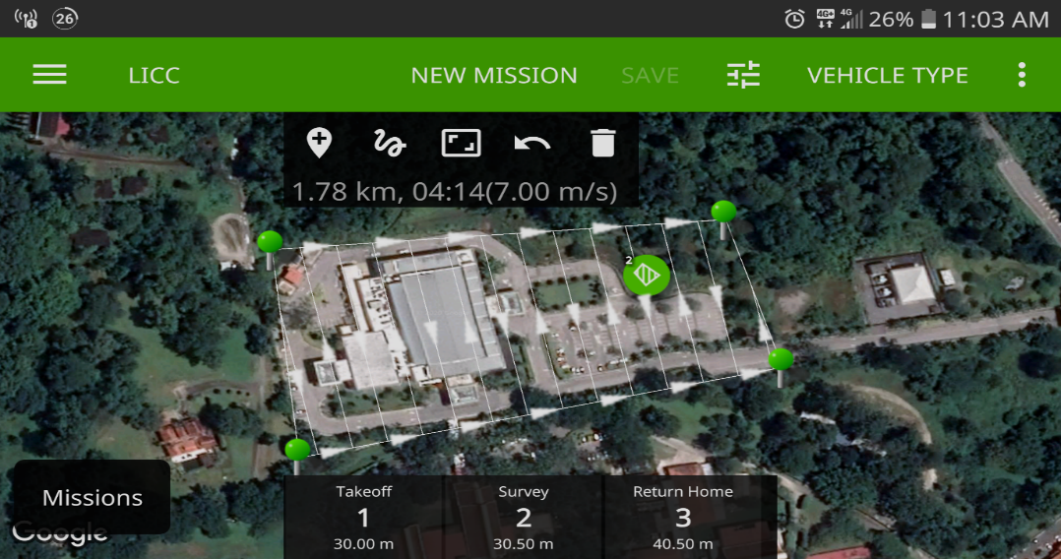

**Automated Flight Mission Example**

**PART C - PERSONNEL LIST FOR THE UAS OPERATION**

The Accountable Manager shall submit the details of **all personnel** involved for the UAS operation in form below:

|  |  |  |  |  |
| --- | --- | --- | --- | --- |
| **No.** | **Name** | **IC Number** | **Mobile Number** | **Designation** |
|  |  |  |  |  |
|  |  |  |  |  |
|  |  |  |  |  |
|  |  |  |  |  |
|  |  |  |  |  |
|  |  |  |  |  |
|  |  |  |  |  |
|  |  |  |  |  |
|  |  |  |  |  |
|  |  |  |  |  |

**DOCUMENT SUBMISSIONS CHECKLIST**

|  |  |  |  |  |
| --- | --- | --- | --- | --- |
| **No.** | **Documents** | **Yes** | **No** | **Remarks** |
| 1. | Accountable Manager Details: |  |  |  |
|  | a. Identification Card / Passport; and |  |  |  |
|  | b. Company Registration Certificate. |  |  |  |
| 2. | SIRIM Approval / Certificate. |  |  |  |
| 3. | MCMC Approval / Certificate1 (if applicable). |  |  |  |
| 4. | JUPEM Approval2 (if required). |  |  |  |
| 5. | Appointment Letter or Landowner permission, undertaking the company for the said task. |  |  |  |
| 6. | Pilot: |  |  |  |
|  | a. Competency Evidence3; and |  |  |  |
|  | b. Identification Card / Passport. |  |  |  |
| 7. | .kml or .kmz file (Google Earth) |  |  |  |
| 8. | UAS User Manual / Specifications Brochure. |  |  |  |

*Application form and supporting documents needs to be submitted at least 14 days before the proposed activity date to [drone.atf@caam.gov.my](mailto:drone.atf@caam.gov.my) to avoid any delay.

1 If UAS requires an Apparatus Assignment. (UAS using Class Assignment – 433 - 435 MHz, 2400 - 2500MHz, 5725 - 5875 MHz falls into Class Assignment and does not required an Apparatus Assignment).

2 If UAS carries camera as payload.

3 Attach remote pilot competency if available. It is not a mandatory requirement as CAAM will evaluate the competency of the pilot via the Risk Assessment.